**Type school name here: Arlington Science Focus**

**Click here for databases**

**Put your login here**

**Click here**

**4. Login with your information**

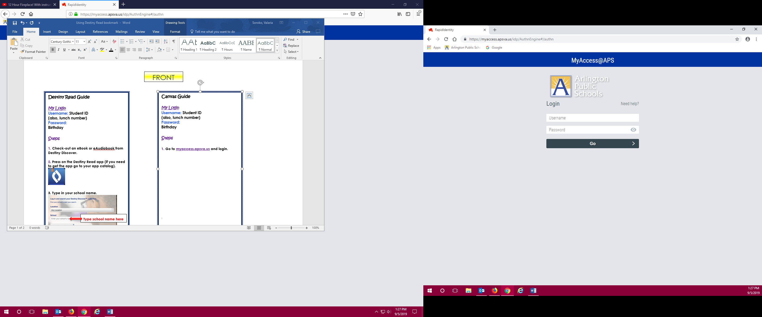

**5. Once in MackinVIA click on the far left for databases or other options.**

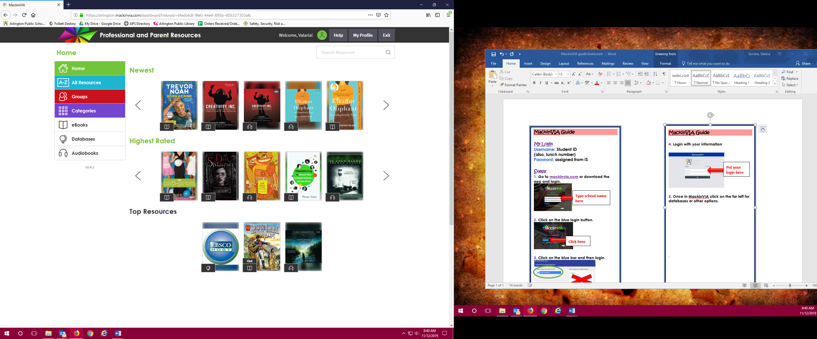

.

**MackinVIA Guide**

**My Login**

**Username: Student ID**

**(also, lunch number)**

**Password: 10 digit school assigned google number**

**Steps**

**1. Go to mackinvia.com or download the app.**

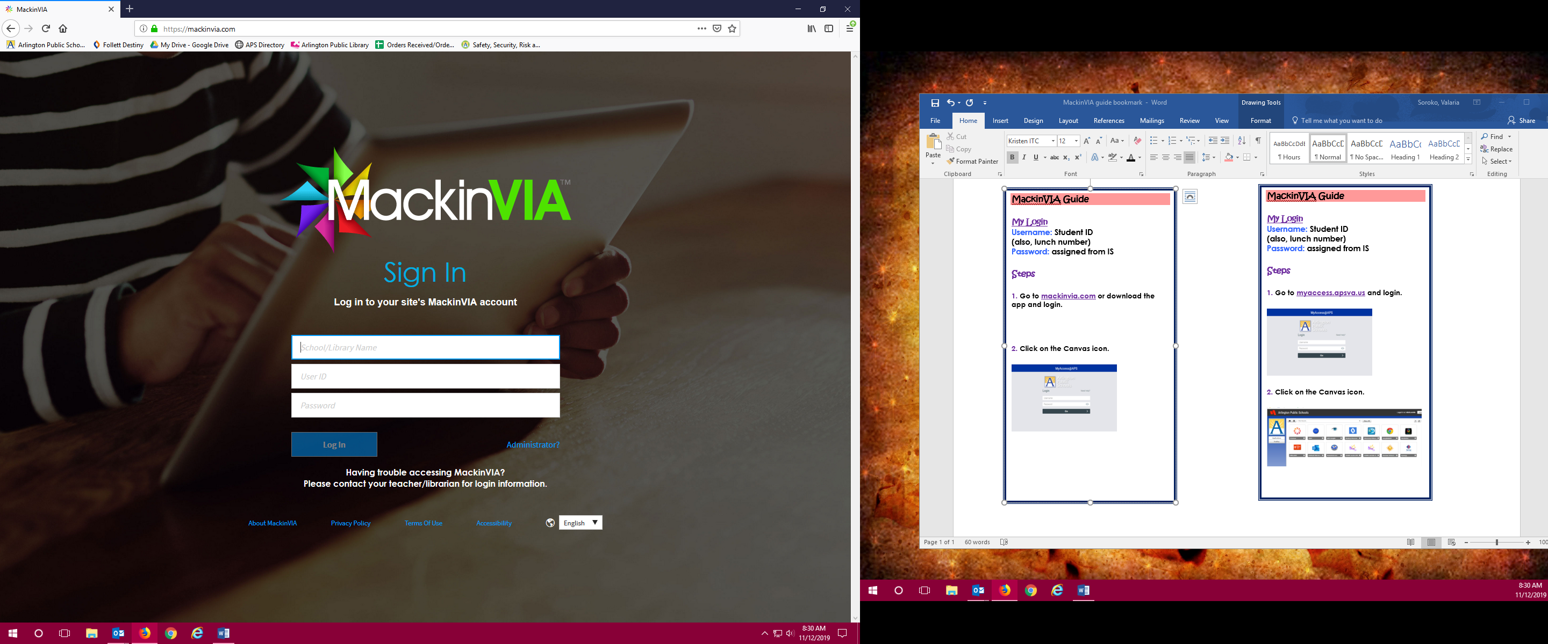

**2. Click on the blue login button.**

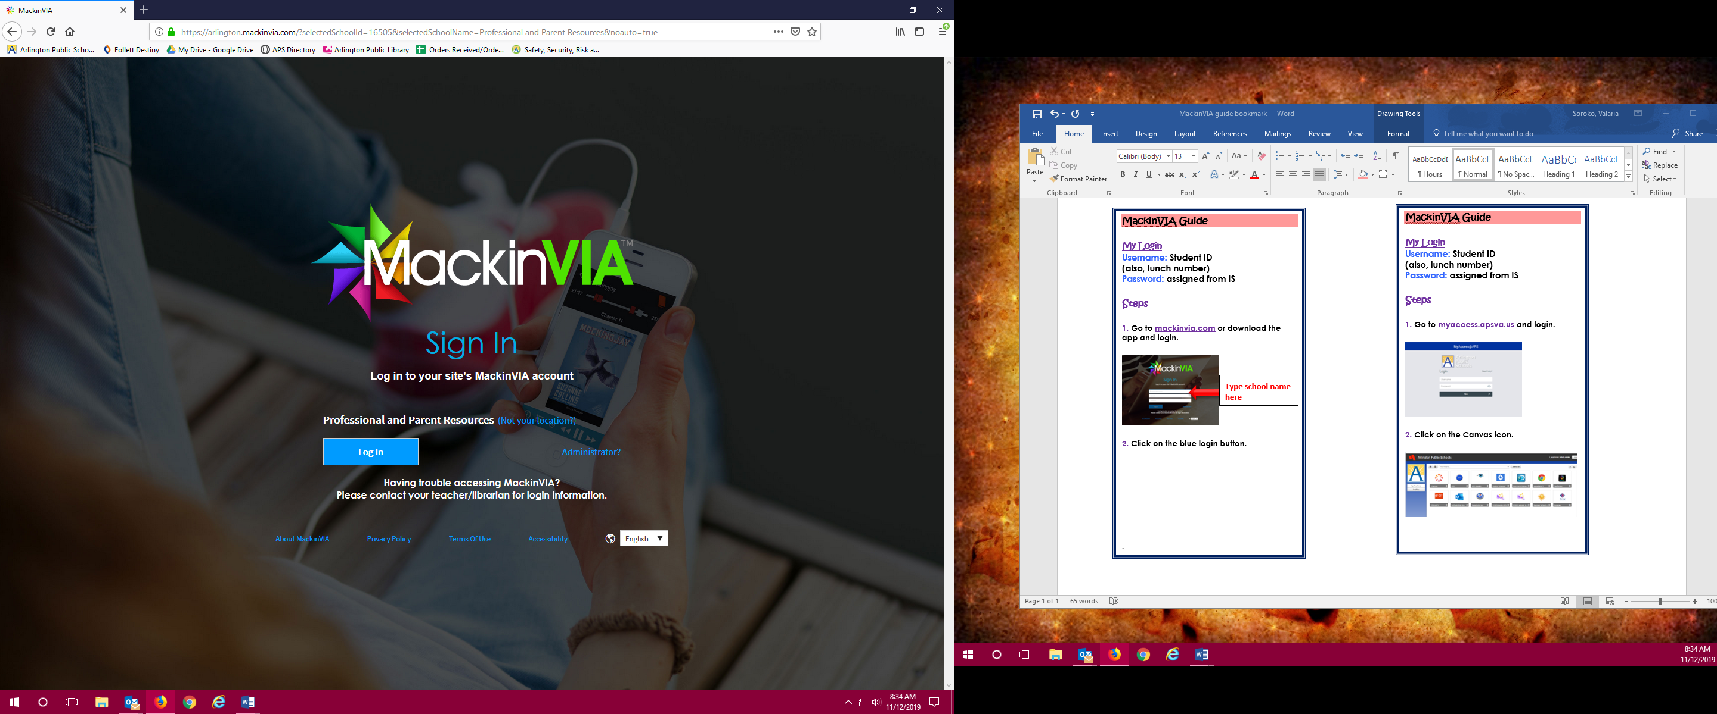

**3. Click on the blue bar and then login.**



