Helpful 1st Grade Apps

Reading Apps:
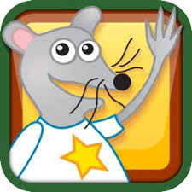
Starfall Learn to Read
Excellent for emerging and beginning readers
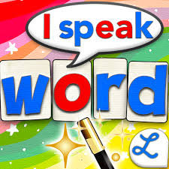
Word Wizard
Phonics & Spelling practice
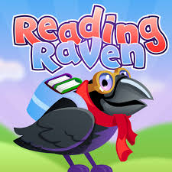
Reading Raven
Volume 1 & 2; self-paced lessons, games, and activities

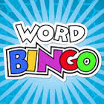
Word Bingo
Games to practice and spell sight words

Writing Apps:
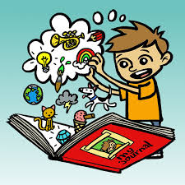
Kids Journal (iPad)
Easy to use for daily reflections and writing
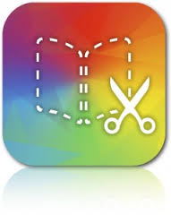
Book Creator (iPad)
Great app for creating and publishing stories

Handwriting Apps:
Letter School

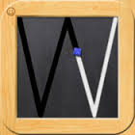
Wet Dry Try (Handwriting Without Tears)

Dexteria (practices fine motor skills)

Math Apps:

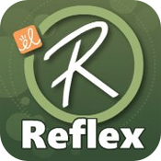 Reflex Math (iPad)
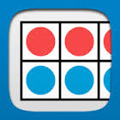
Number Frames (Math Learning Center)
All Math Learning Center apps are excellent. Also look at Geoboard,
Pattern Shapes, Number Line, & Number Rack apps
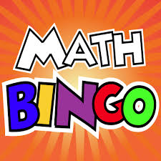
Math Bingo
Math fact practice for addition, subtraction, multiplication, & division
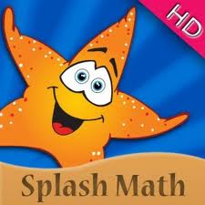
Splash Math
Practices math facts and concepts for multiple grades

Science Apps:

Crazy Gears
Builds logical thinking skills and knowledge of physics concepts
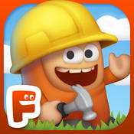 Inventioneers

Multiple Subject Apps:

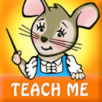
Teach Me 1st Grade
Games that reinforce sight words, spelling, addition, and subtraction

