5th Grade Music Lesson, Part 1 of 2

- Go to the following link to learn all about sound. You can click on each picture to learn more about each section: https://www.dkfindout.com/us/science/sound/
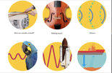

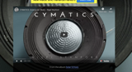
- Then follow this link to view a video called “Cymatics.” It is a really awesome video that shows some ways sound can actually be seen! https://nigelstanford.com/Cymatics/

*If you scroll down the page, you can see some behind the scenes moments.

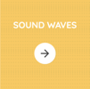
- Go to Chrome Music Lab and click on the sound waves section. Explore what high/low notes do to the sound waves. https://musiclab.chromeexperiments.com/Sound-Waves/

- What do you notice about how the sound waves move when you play the lowest note? The highest note? One in the middle?

5th Grade Music Lesson, Part 2 of 2

Write your own Rap!
Be ready to share with your class when we see you next time!

Objective: Students will write a 4-measure name rap within the specified structure and create a rhythmic backing to accompany themselves.

Rap Structure
Tempo 80-90 BPM

Step One:
Hey, I’m ________ and I like to ___________ (in this line, say something about thing you like. The final word in this line should rhyme with the end of line 1)
I like that
Oh yeah, I like that
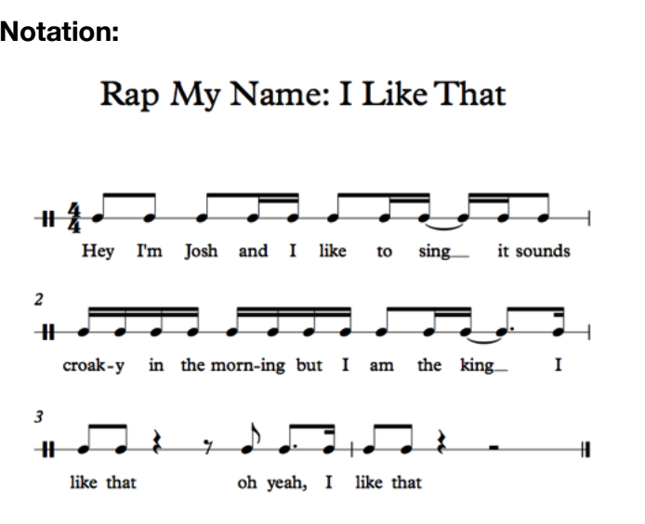

Example 1: (by a grade 4 student)
Hey I’m Josh and I like to sing
It sounds croaky in the morning but I am the king
I like that
Oh yeah, I like that

Example 2:
Hey I’m Ava and I like the color blue
It makes me happy, so what you gonna do?
I like that
Oh yeah, I like that

Step Two:

Option 1: Groove Pizza
- Visit Groove Pizza (free online rhythmic step sequencer)
  - https://apps.musedlab.org/groovepizza/?museid=Hkg8iiIrI&
- Set the tempo to 80 BPM
- Build up a rhythmic pattern by clicking on the dots on the “pizza” or in the drum pattern grid (it’s a good idea to start with the bass drum on beats 1 and 3 and the snare on beats 2 and 4 and then add other sounds
Option 2: Incredibox
- Visit Incredibox (free online program)
- Drag a sound icon on to one of the “dudes” on the screen and he will start to beatbox or sing.
- Try performing your rap along with your creation.
Option 3: GarageBand on iPad
- Open the GarageBand app and create a new song
- Select the Smart Drums
- Choose a drum kit and drag instruments on to the grid to build up a rhythmic pattern
- Press Record and record 8 measures
Extensions:
- If your music software/app allows, add an audio track and record the rap part over the backing. Other instrumental backing parts can be added as well: bass line, keyboard part, strings and so on.
- Create a series of dance moves to go with your rap
  - Try out some breakdance moves!
  - https://drive.google.com/drive/folders/1K4xPUQoMGR9oSWPwJCDrc6_iqLjagAtP?usp=sharing
- Perform your rap live for family members
- Draw some cover art for your album!
Extra Credit! Play with this Google Doodle and learn more about the History of Hip Hop
https://www.google.com/doodles/44th-anniversary-of-the-birth-of-hip-hop

Lesson adapted from Midnight Music: https://midnightmusic.com.au/

